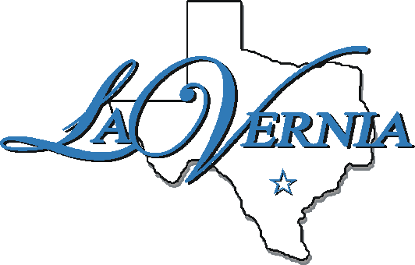
City of La Vernia
NOTICE OF POSSIBLE QUORUM

La Vernia City Park
222 San Antonio Rd, La Vernia, Texas 78121

October 6, 2015
6:00 p.m.

AGENDA

1. Notice is hereby given that a quorum of the members of the City Council may be present at the place and time listed above for the purpose of National Night Out. No action of the City Council will be taken at this event.

The City Council for the City of La Vernia reserves the right to adjourn into executive session at any time during the course of this meeting to discuss any of the matters listed above, as authorized by the Texas Open Meetings Act, Texas Governmental Code §§ 551.071 (Consultation with Attorney), 551.072 (Deliberations about Real Property), 551.073 (Deliberations about Gifts and Donations), 551.074 (Personnel Matters), 551.076 (Deliberation about Security Devices), and 551.086 (Economic Development), and any other provision under Texas law that permits a governmental body to discuss a matter in a closed executive session.

I, the undersigned authority, do hereby certify that the above Notice of Meeting of the governing body of the above named La Vernia City Council is a true and correct copy of said Notice and that I posted a true and correct copy of said Notice on the bulletin boards, of the City Hall of said City of La Vernia, Texas, a place convenient and readily accessible to the general public at all times, and said Notice was posted on October 2, 2051 at 9:30 A.M. and remained so posted continuously for at least 72 hours preceding the scheduled time of said meeting.

_______________________________
Brittani Porter, City Secretary

